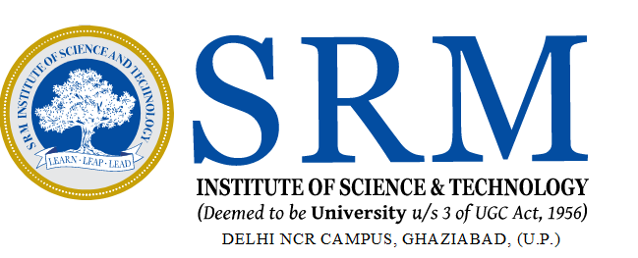

SRM INSTITUTE OF SCIENCE & TECHNOLOGY
(FACULTY OF SCIENCE & HUMANITIES)
DEPARTMENT OF COMPUTER APPLICATIONS

PRACTICAL FILE

PYTHON PROGRAMMING

[PCA20C04J]
MCA- 1st YEAR, 2nd SEMESTER
Session: 2024-25

SUBMITTED TO : | SUBMITTED BY :
Faculty Name: Mr. XXXXXXXXXXXXXXXXXXX |  | Student Reg No: XXXXXXXXXXXXXXX
Designation : Assistant Professor |  | Student Name: XXXXXXXXXXXXXX
Department of Computer Applications | Department of Computer Applications

SRM INSTITUTE OF SCIENCE & TECHNOLOGY
DELHI NCR CAMPUS, MODINAGAR
(FACULTY OF SCIENCE & HUMANITIES)
DEPARTMENT OF COMPUTER APPLICATIONS

Registration No. :
XXXXXXXXXXXXXXX

BONAFIDE CERTIFICATE

Certified to be the Bonafide record of the work done by XXXXXXXXXXXXXX of MCA 1st Year/ 2nd Semester for the Award of Master's Degree in the DEPARTMENT OF COMPUTER APPLICATIONS in PYTHON PROGRAMMING [PCA20C04J] laboratory during the Academic Year 2024-25.

SUBJECT IN – CHARGE HEAD – COMPUTER APPLICATIONS

Submitted for the University Examination held on __________________________.

INTERNAL EXAMINER - 1 INTERNAL EXAMINER - 2

TABLE OF CONTENTS

S.  NO | PROGRAM TITLE | DATE | PAGE NO | SIGNATURE
1 | Write a program to purposefully raise Indentation Error and correct it. | 18-12-2024 | 1
2 | Write a program to compute distance between two points taking input from  the user (Pythagorean Theorem). | 18-12-2024 | 3
3 | Write a program add.py that takes 2 numbers as command line arguments and  prints its sum. | 08-01-2025 | 5
4 | Python program to swap two variables without using third variable. | 08-01-2025 | 7
5 | Write a program to verify the number is odd, even or prime. | 15-01-2025 | 8
6 | Write a program to find out the positive and negative number in list. | 15-01-2025 | 10
7 | Write a program to find the median of the tuples. | 15-01-2025 | 12
8 | Write a program for finding whether the string is palindrome or not. | 22-01-2025 | 14
9 | Write a function for breaking the set into the list of the sets. | 22-01-25 | 16
10 | Write a program for printing the cube of list elements using lambda. | 22-01-25 | 18

TABLE OF CONTENTS

S.  NO | PROGRAM TITLE | DATE | PAGE NO | SIGNATURE
9 | Implement option Menu. | 07-02-2025
10 | Set and retrieve shared preferences. | 14-02-2025
11 | Implement SQLite Database in an app. | 21-02-2025
12 | Develop a standard calculator application to perform basic calculations like addition, subtraction, multiplication and division. | 28-02-2025
13 | Draw an object. | 07-03-2025
14 | Implement webview. | 14-03-2025
15 | Implement an application that creates an alert upon receiving a message. | 21-03-2025

PROGRAM 1

AIM: Write a program to create Login page with toast message as “Welcome to the Android World”

PROCEDURE / ALGORITHM:
- WRITE STEPS AND PROCEDURE HERE

CODE:
- WRITE XML AND JAVA CODE HERE

OUTPUT:
- PASTE THE SCREENSHOT HERE

RESULT: The program is completed and executed successfully.

#replace the Red color lines with your apt. content.

